SARCINĂ TEHNICĂ
Actualizarea site-ului „Eu4civilsociety.md”

Elaborator: Laurenția OSTROFEȚ
Coordonator de proiecte al S.C. „Rețele Terestre” S.R.L.
Coordonator: Victor CIOCLEA
Administrator al S.C. „Rețele Terestre” S.R.L.

Chișinău 2020

Contents:
I. Introduction 2
II. Technical Requirements 2
2.1. The standards used to develop the portal 3
2.2. Technical compenents 3
2.3. Server architecture 3
III. Functional Requirements 4
3.1. Website Design 4
3.2. Platform functionalities 5
IV. Proposed Tasks 11
V. Deliverables and implementation schedule 13

- Introducere

This document includes the description of the concept of developing the modules/adjustments described in the ToR (according to the proposed timeframe) and explains our understanding of the objective.
The aim of the Project website is to inform the people, local and regional non-governmental organizations, local and national public authorities, and other stakeholders about the Project, its results and impacts, the role of the partners as well as EU’s support and funding provided to the Project. The website offers beneficiaries and stakeholders adequate and accessible informative tools and instruments.
- Technical Requirements

  - The standards used to develop the portal
The design of the information system will meet compatibility and accessibility requirements in accordance with national and international specifications, such as the W3C (World Wide Web Consortium, May 5, 1999) and WAI (Web Accessibility Initiative) recommendations, accepted worldwide as international standards. in the field of web accessibility.
The content of the site will be correctly displayed on all major Internet browsers (Internet Explorer, Microsoft Edge, Mozilla Firefox, Google Chrome) with all versions of them, but not older than 2 years.
  - Technical compenents
The system will be implemented with the help of the Laravel framework, written in the PHP language, which has the possibility of developing the platform using HTML, CSS, Bootstrap, Stylus and JavaScript. The MySQL system is used to manage the databases.
Laravel Framework - we propose to use this platform if necessary due to its scalability and the possibility of creating different information systems, regardless of its level of complexity. Due to its possibilities, this platform has become the number 1 in the world.
  - Server architecture

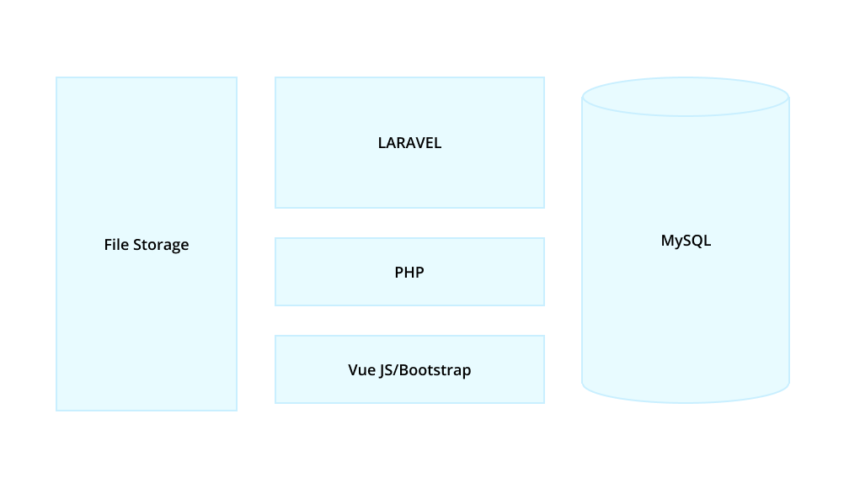
- Functional Requirements

“The website and its modules, existing and new, will contain relevant information for different audiences that will cover a wide range of population categories and specialists from various fields of activity, besides the site will serve as a secured platform for submission of online applications and online feedback and complaints mechanism. It is necessary that the new modules will ensure an efficient communication tool which will meet the technical, navigation, content, and maintenance requirements.”

  - Website Design
The design of the new modules will match the existing modules/pages.
The design of the platform must be attractive, and the warm and vivid colors should motivate visitors to access the platform as often as possible.
The platform must have a clear, neat and easy-to-use structure and navigation, as well as a responsive design that fits any device and format.

  - Platform functionalities
- Content manager system
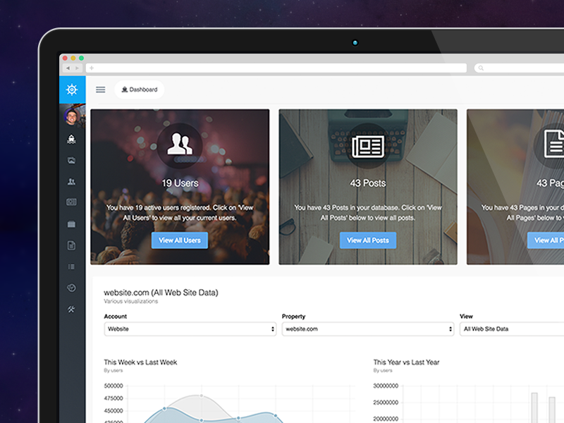
Voyager is a Laravel Admin Package that includes BREAD(CRUD) operations, a media manager, menu builder, and much more.
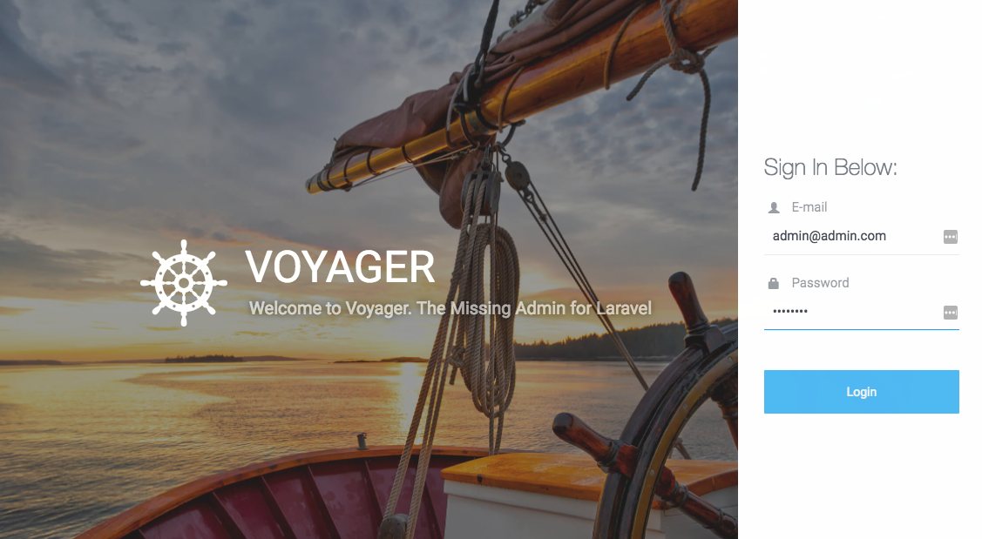

Voyager has a full-fledged Media Manager which allows you to upload files, re-name files, and delete files. You can also add new folders and move files/folders. Basically, anything that you would be able to do in any type of Media Manager you can do so in the Voyager Media Manager.
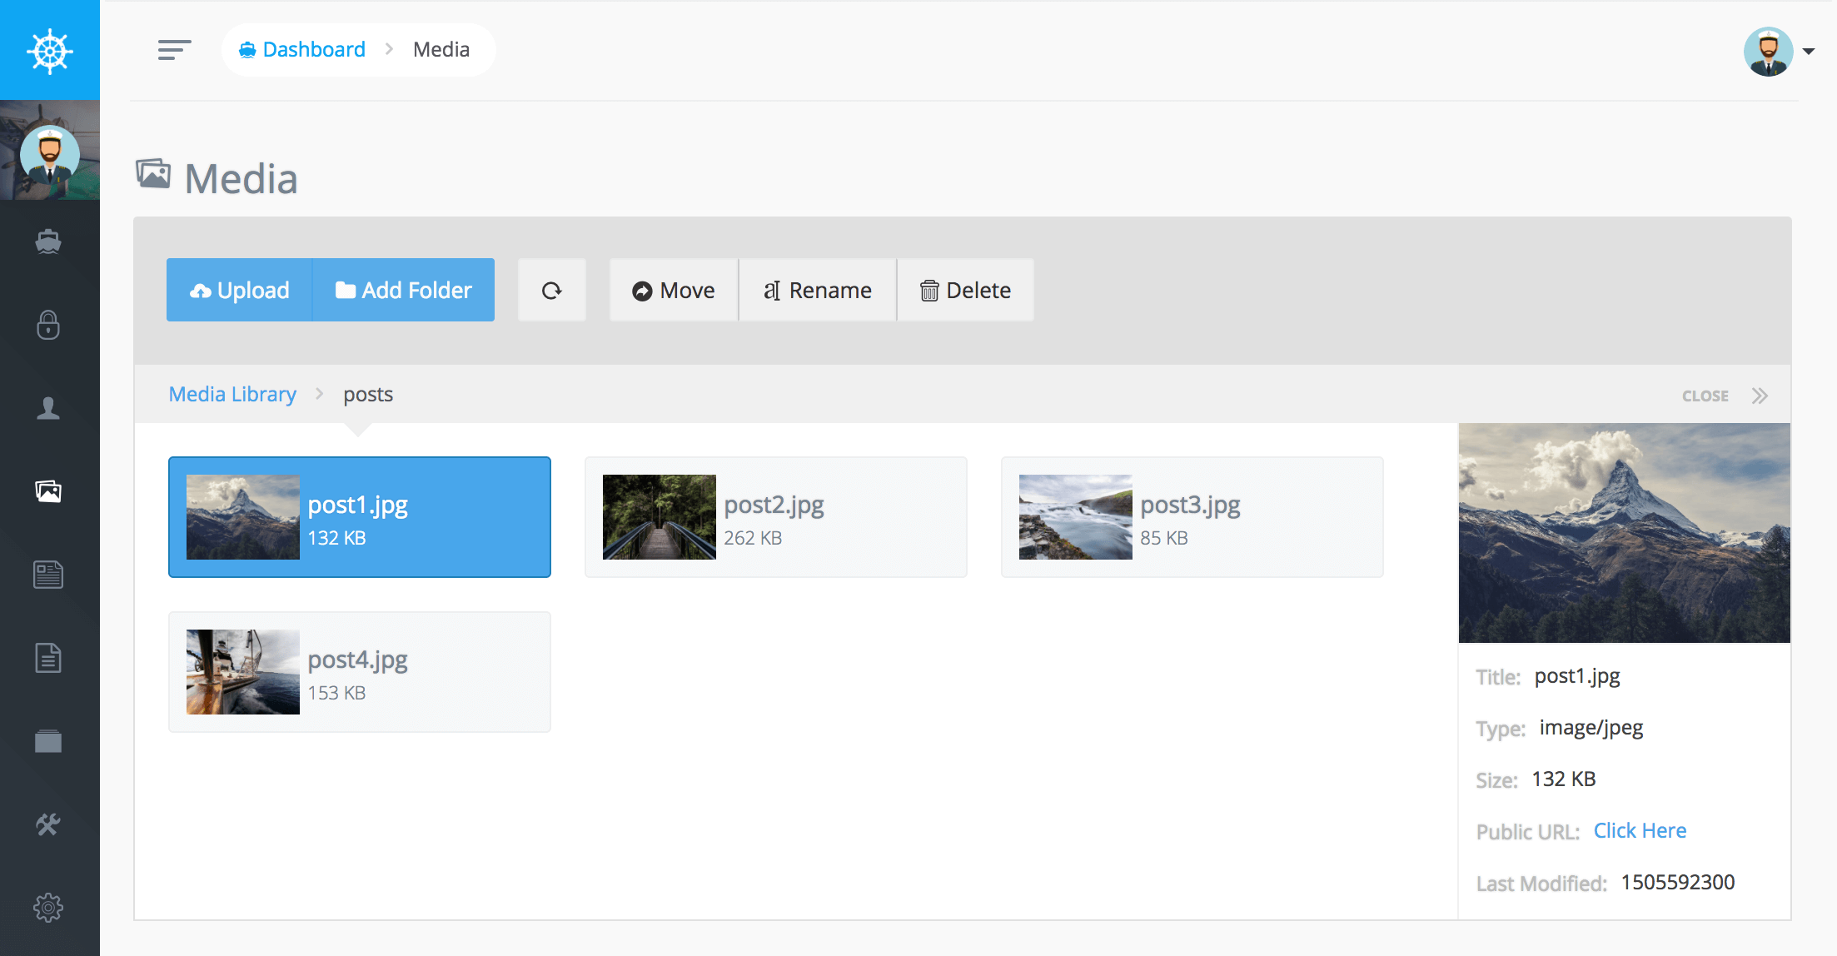
You may also drag and drop files onto the 'upload' button to upload multiple files. The media manager allows you to create thumbnails and add watermarks to uploaded images through the configuration file.
With Voyager you can easily create menus for your application. In fact the Voyager admin is using the menu builder for the navigation you use on the left hand side.
You can view your current Menus by clicking on the Tools->Menu Builder button. You can add, edit, or delete any current menu. This means that you can create a new menu for the header, sidebar, or footer of your site. Create as many menus as you would like.
When you are ready to add menu items to your menu you can click on the builder button of the corresponding menu:
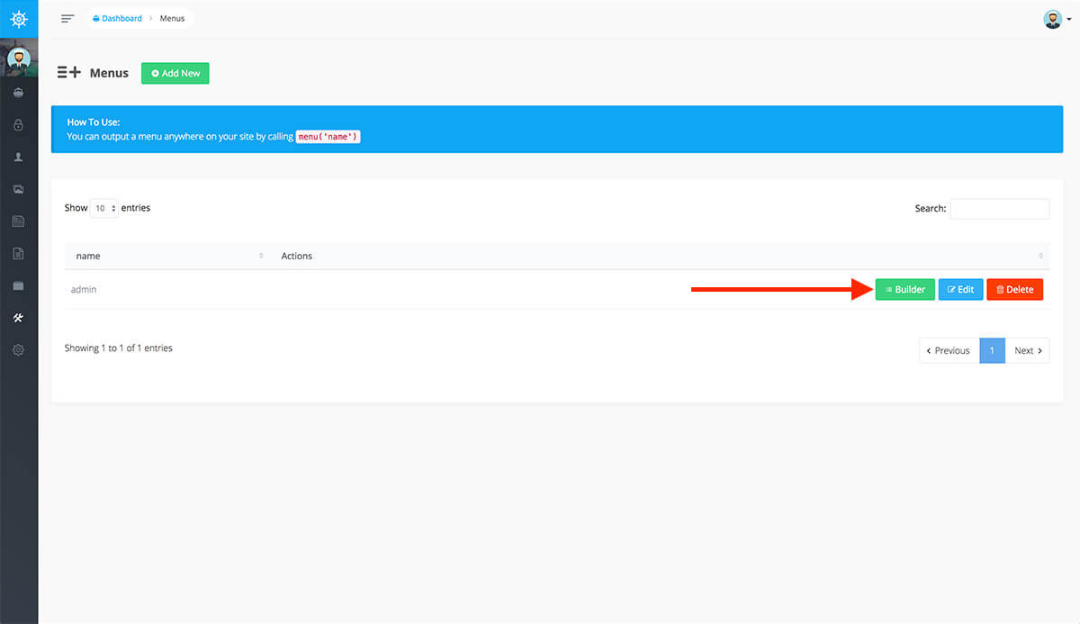
This will take you to the Menu Builder where you can add, edit, and delete menu items.
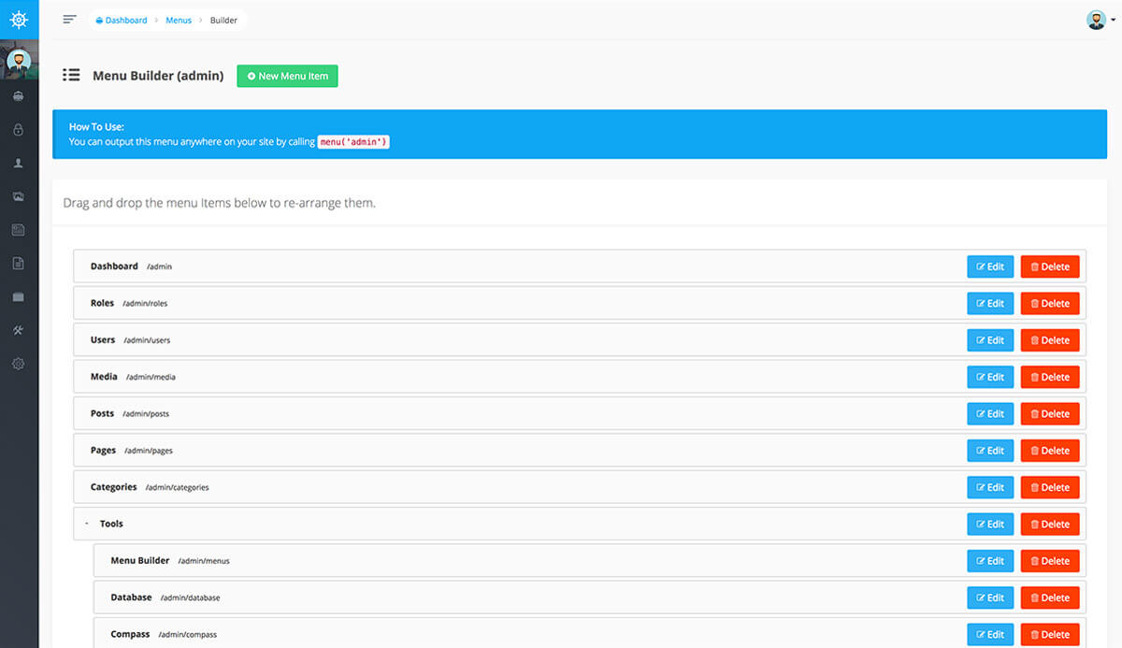

Voyager has some awesome database tools which allow you to Add/Edit/Delete or view current database tables. The other cool part of Voyager is that you can add BREAD or (Browse, Read, Edit, Add, & Delete) functionality to any of your tables.
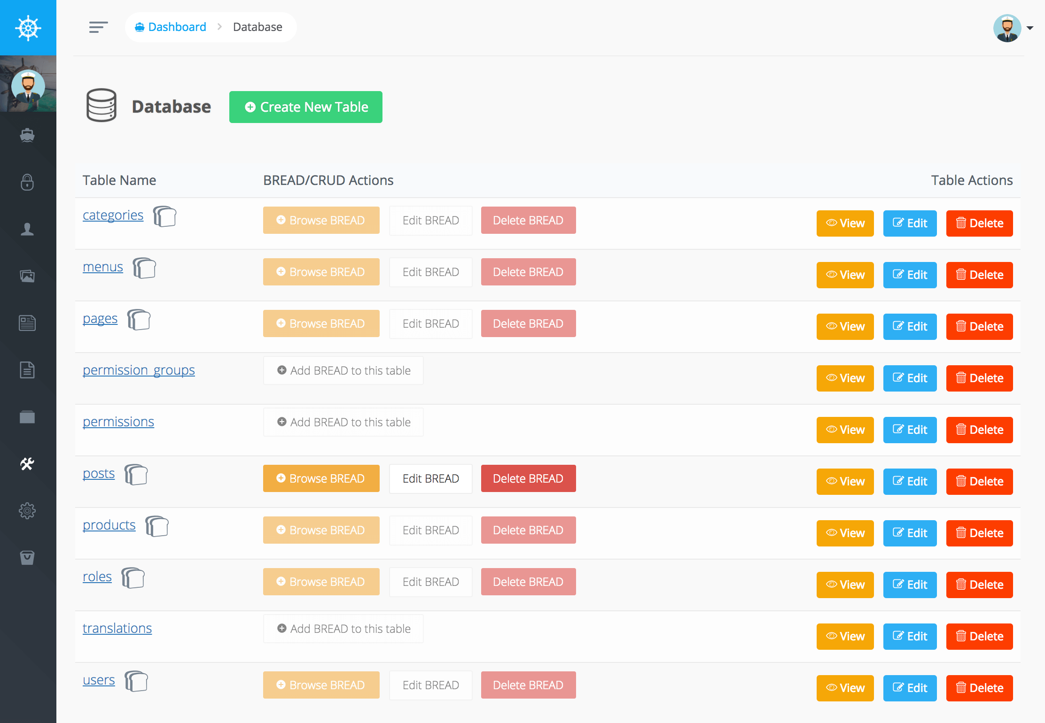
Inside of your admin panel you can visit Tools->Database and you'll be able to view all your current tables in your database. You may also click on 'Create a New Table' to create a new table in your database. All newly created tables will use the charset defined in your default database connection.

The Settings section allows you to add any site wide settings you would like. You can add an image upload setting for your site logo or a text box for the main headline on your homepage.
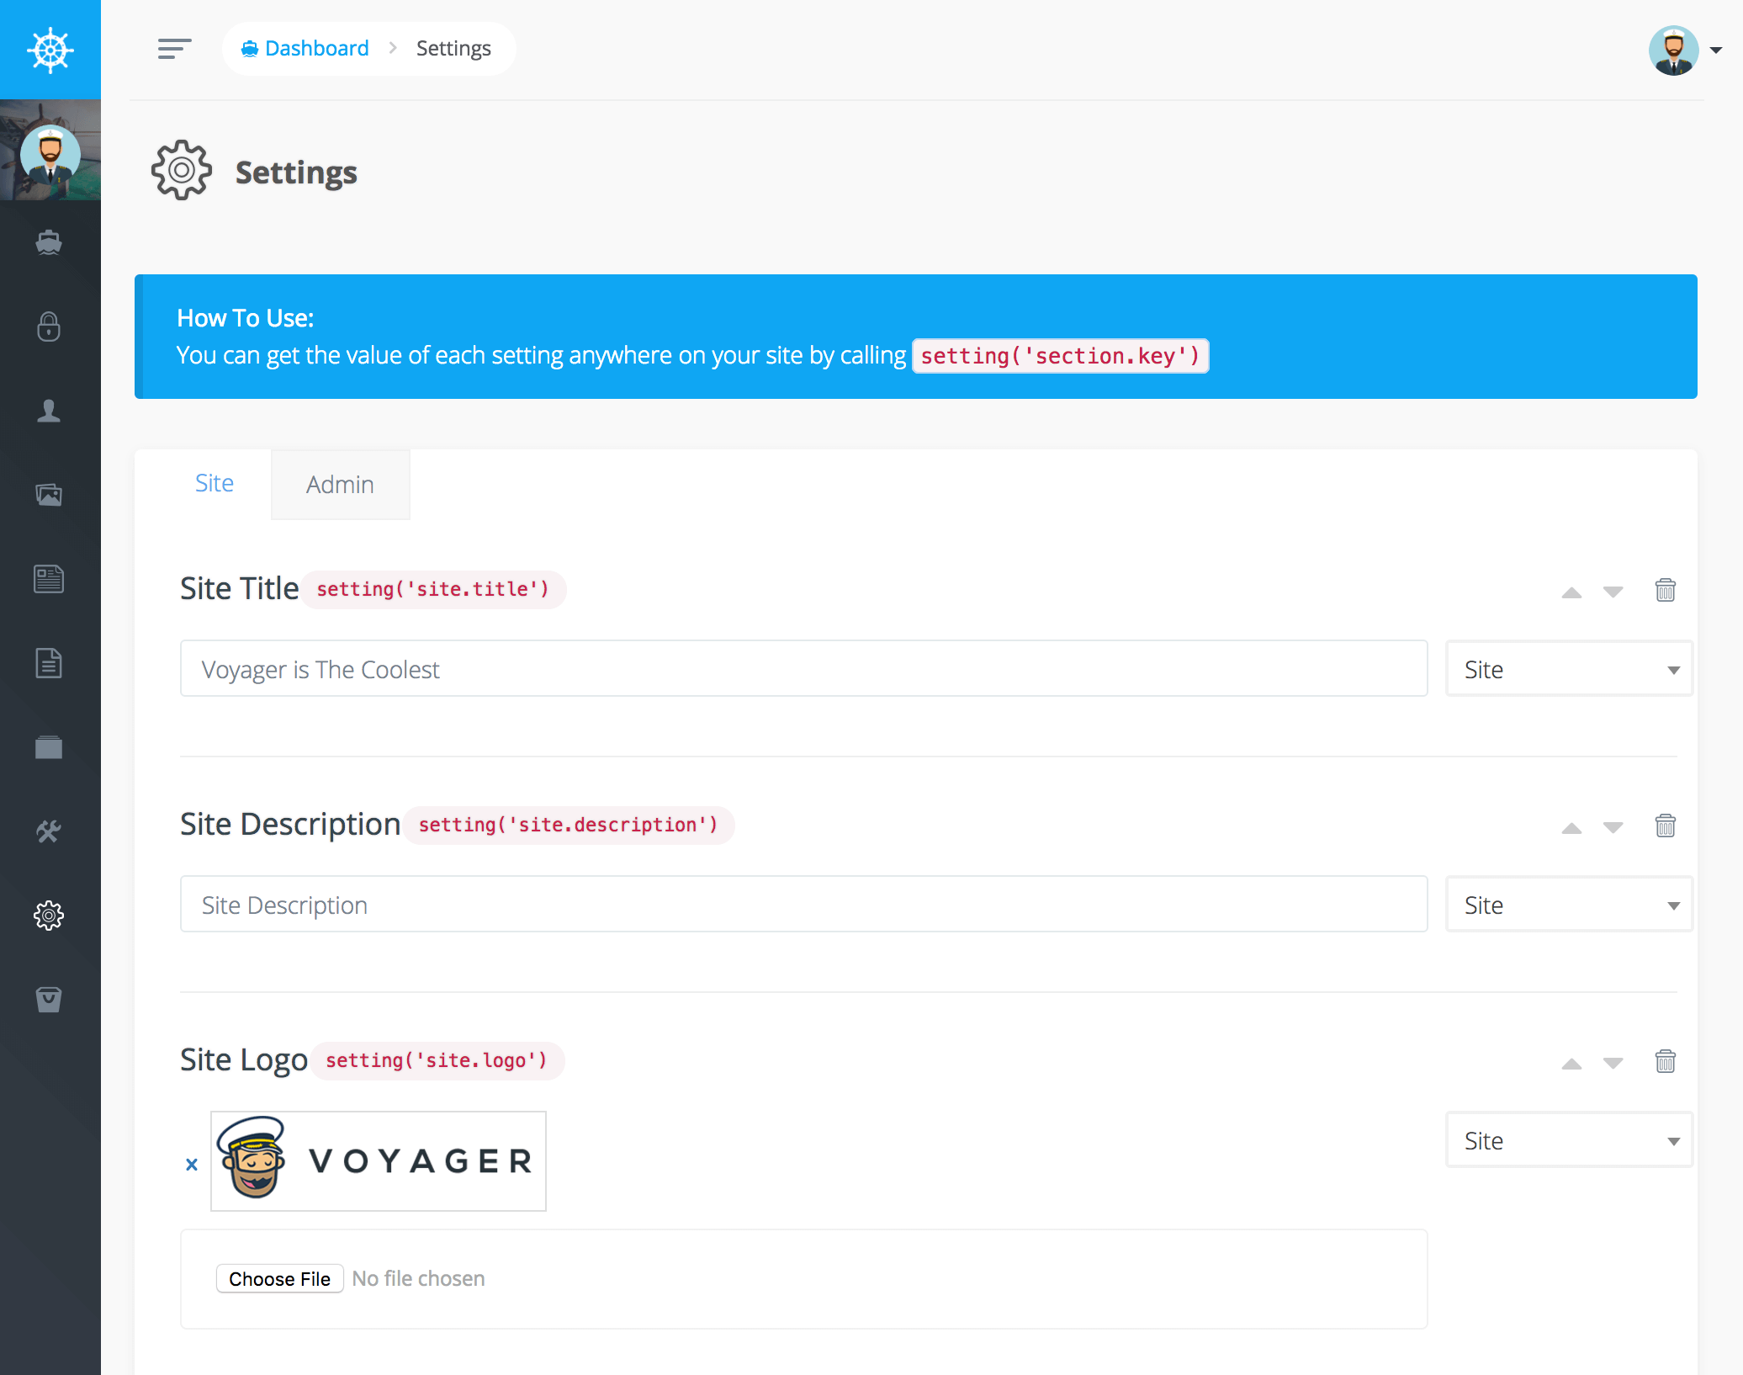

- Language Specifications
The new modules will be developed in 3 languages: Romanian, Russian and English, providing a correct display of content.
Voyager has a module that allows running fully multilingual websites with Laravel, making it easy to translate pages, posts, tags and categories.
- Requirements to access rights management
The permissions and roles modules give the possibility to define different groups of users and grant different user permisions. The authentication mechanism is based on login (email) and password.
- Optimization for social network

We will develop a module that will make it easy for your audience to share articles, images, products and activities from your website to their social networks. Integrations include Facebook, Twitter, Pinterest, Google, WhatsApp, LinkedIn, Reddit, etc.

- Proposed Tasks

- Design, develop and deploy the module as resource page for photo, video, audio and documents sharing;
This module will allow uploading the needed files to the system and displaying them in the designed way (we will provide the design variants, according to the discussion with GIZ Project team)
- Design, develop and deploy self-standing feedback module, with reply/chat options;
We will come with different options for chat such as 3cx, jivochat, etc and provide a individual feedback module for each call.
- Design, develop and deploy additional (at least two) modules for online application to multiple calls, with options for archiving of information from previous calls;
The platform will have different modules for multiple calls, and will give the possibility to choose the options individually for each call. All of them will be easy to manage and similar in nature.
- Design and develop module for simple and user-friendly online personal cabinets for prospective applicants;
Each applicant will have an online cabinet with the needed information (the documents he/she uploaded for an application, date, etc). This cabinet will be user friendly and easy to manage for non-specialists.
- Upgrade the Q&A module in line with different calls for applications and categories;
Each call will have its own Q&A module, which will be similar to the existing one and would be accessed from the voyager panel.
- Design and develop digital content (at least 3 banners) for visibility and promotional purposes;
Our designers will provide some digital content according to the preferences and requirements of the GIZ team.
- Update the manual/guidelines how to maintain and administrate the website and its platforms;
RTS will provide the manual with detailed instruction for using the platform in electronic and physical way.
- Deliver in-house info session for the Project staff and its partners appointed for maintaining and administrating the website and online platforms, including technical proposals on how to transfer all the material to any other website once the Project is completed;
Once the site is completed, RTS will assure the transfer of the material from the test platform to the real platform and will teach the staff how to efficiently use the platform’s functionalities and how to administrate the platform correctly. Any questions will be answered.
- Ensure development maintenance services, error fixing and support for the website and its platforms during the upgrade works and after launching of the new pages and platforms.
RTS will provide support through a ticketing system, named Redmine of through email. Any bugs will be eliminated during the maintenance period.
The company also will perform other related tasks, which may emerge during the implementation of the assignment.
- Deliverables and implementation schedule

No. | Work result | Duration (work days)
 | Draft of the concept of the new website pages and modules | 3
 | First draft of the detailed technical specification and business requirements document | 5
 | Design, develop and deploy the module as resource page for photo, video, audio and documents sharing | 10
 | Functioning feedback module, with reply/chat options | 5
 | Functioning additional modules for online application to multiple calls, with options for archiving of information from previous calls | 5
 | Functioning simple and user-friendly online personal cabinets for prospective applicants | 10
 | Upgraded Q&A module in line with different calls for applications and categories | 3
 | In-house info session how to maintain and administer the website and online platforms | 1
 | Updated manual/guidelines how to maintain and administrate the website and platforms | 2
 | Total | 44

